25.40: a) Thyrite resistor:
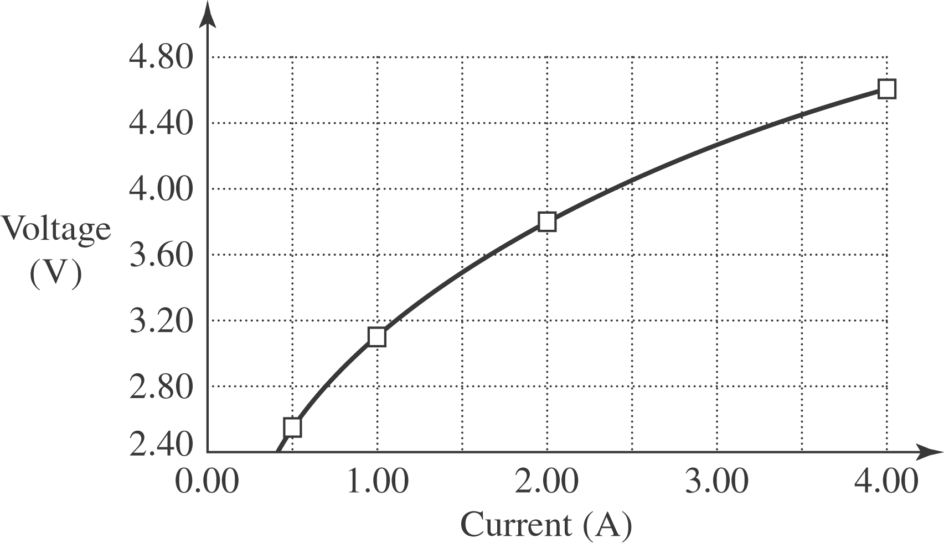

b) The Thyrite is non-Ohmic since the plot is curved.
c) Calculating the resistance at each point by voltage divided by current:

